1. **Creating PivotCharts**

A pivot chart is the visual representation of a pivot table in Excel. Pivot charts and pivot tables are connected with each other.

Below you can find a two-dimensional pivot table. Go back to [Pivot Tables](https://www.excel-easy.com/data-analysis/pivot-tables.html#two-dimensional-pivot-table) to learn how to create this pivot table.

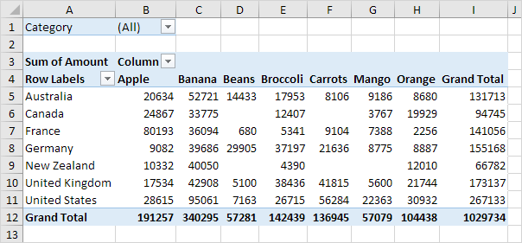

### Insert Pivot Chart

To insert a pivot chart, execute the following steps.

1. Click any cell inside the pivot table.

2. On the PivotTable Analyze tab, in the Tools group, click PivotChart.

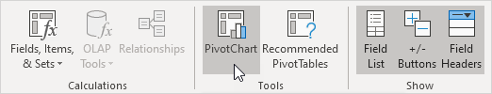

The Insert Chart dialog box appears.

3. Click OK.

Below you can find the pivot chart. This pivot chart will amaze and impress your boss.

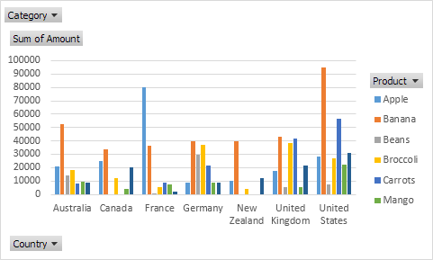

Note: any changes you make to the pivot chart are immediately reflected in the pivot table and vice versa.

You have read the first part of this article. You're doing splendidly! Keep reading for more useful information.

1. **Filtering PivotTable Data**

To filter this pivot chart, execute the following steps.

1. Use the standard filters (triangles next to Product and Country). For example, use the Country filter to only show the total amount of each product exported to the United States.

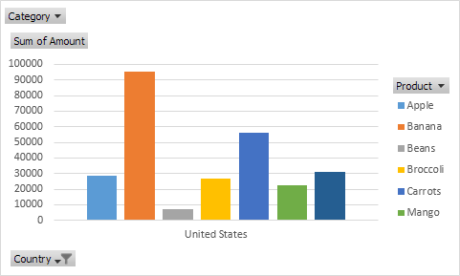

2. Remove the Country filter.

3. Because we added the Category field to the Filters area, we can filter this pivot chart (and pivot table) by Category. For example, use the Category filter to only show the vegetables exported to each country.

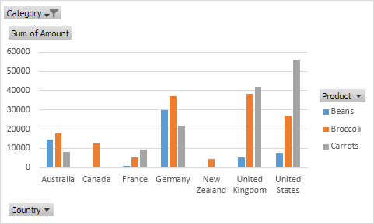

### Change Pivot Chart Type

You can change to a different type of pivot chart at any time.

1. Select the chart.

2. On the Design tab, in the Type group, click Change Chart Type.

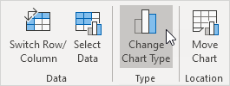

3. Choose Pie.

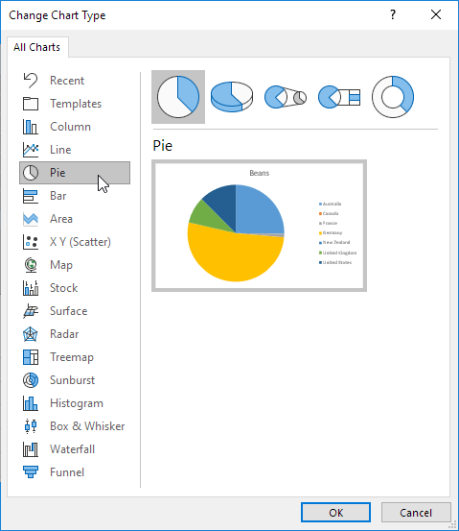

4. Click OK.

Result:

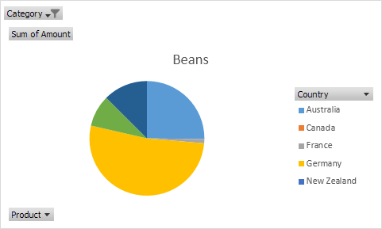

Note: pie charts always use one data series (in this case, Beans). To get a pivot chart of a country, swap the data over the axis. First, select the chart. Next, on the Design tab, in the Data group, click Switch Row/Column.

1. **Filtering with the Slicer Tool**

To understand the usage of slicers, consider the example of sales data region-wise, month wise and salesperson-wise. Assume you have the following PivotTable with this data.

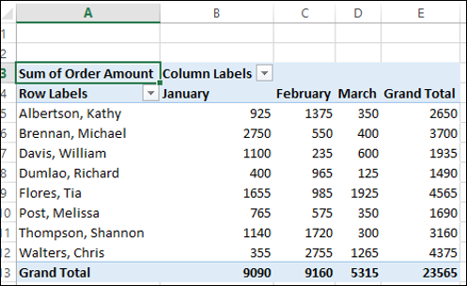

## Inserting Slicers

Suppose you want to filter this Pivot Table based on the fields – Region and Month.

* Click on ANALYZE under PivotTable TOOLS on the Ribbon.
* Click on Insert Slicer in the Filter group. The Insert Slicers dialog box appears. It contains all the fields from your data table.
* Check the boxes Region and Month.
* Click OK.

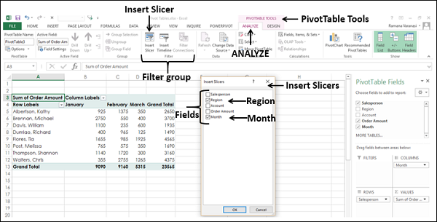

Slicers for each of the selected fields appear with all the values selected by default. Slicer Tools appear on the Ribbon to work on the Slicer settings, look and feel.

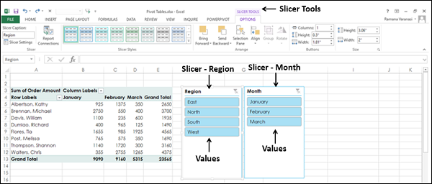

## Filtering with Slicers

As you can observe, each slicer has all the values of the field that it represents and the values are displayed as buttons. By default, all the values of a field are selected and hence all the buttons are highlighted.

Suppose you want to display the PivotTable only for the regions South and West and for the Months of February and March.

* Click on South in the Slicer for Region. Only South will be highlighted in the Slicer – Region.
* Keep Ctrl key pressed and click on West in the Slicer for Region.
* Click on February in the Slicer for Month.
* Keep Ctrl key pressed and click on March in the Slicer for Month.

Selected items in the Slicers are highlighted. PivotTable with summarized values for the selected items will be displayed.

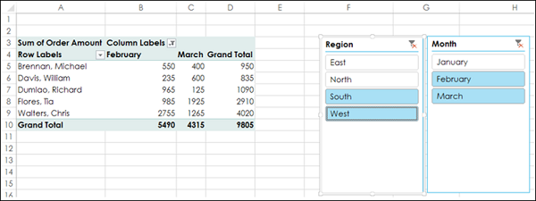

To add/remove values of a field from the filter, keep the Ctrl key pressed and click on those buttons in the slicer of the field.

1. **Excel Power Pivot**

**Definition**:

Excel Power Pivot is an add-in tool for Microsoft Excel that allows users to perform advanced data analysis and create data models using large datasets from various sources.

**Example**:

Imagine you have a dataset containing sales information from multiple regions and product categories. With Power Pivot, you can efficiently analyze this data, create relationships between different tables, and generate insightful reports to identify trends and make informed business decisions.

**UseCase**: A retail company wants to analyze its sales data to understand customer purchasing behavior and optimize its product offerings. By using Power Pivot, they can consolidate sales data from different sources, create relationships between customer, product, and sales tables, and generate dynamic reports with slicers and pivot charts to visualize sales performance across different regions and product categories

1. **Activating the Excel PowerPivot AddIn**

Power Pivot is an add-in that you can use to perform powerful data analysis in Excel. The add-in is built into certain versions of Office, but by default, it's not enabled.

Here’s how you enable Power Pivot before using it for the first time.

1. Go to **File** > **Options** > **Add-Ins**.
2. In the **Manage** box, click **COM Add-ins**> **Go**.
3. Check the **Microsoft Office Power Pivot** box, and then click **OK**. If you have other versions of the Power Pivot add-in installed, those versions are also listed in the COM Add-ins list. Be sure to select the Power Pivot add-in for Excel.

The ribbon now has a Power Pivot tab.

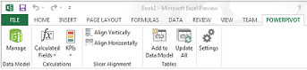

## Open the Power Pivot window

1. Click **Power Pivot**.  
   This is the tab where you work with Power Pivot PivotTables, calculated fields, and key performance indicators (KPIs), and creating linked tables.
2. Click **Manage**.  
   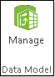

Now you’re in the Power Pivot window. Here you can click Get External Data to use the Table Import Wizard to filter data as you add it to your file, create relationships between tables, enrich the data with calculations and expressions, and then use this data to create PivotTables and PivotCharts.

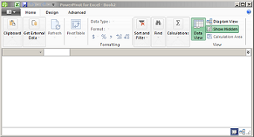

1. **Creating Data Models with PowerPivot**

**Definition:**

Data modeling in Power Pivot involves creating relationships between different tables in a data model to establish connections and enable efficient data analysis.

**Example**:

Suppose you have separate tables for sales transactions, customer information, and product details. By creating relationships between these tables based on common fields (e.g., customer ID, product ID), you can establish a data model that allows you to analyze sales by customer segment, product category, and geographical region seamlessly.Use Case:A financial institution wants to analyze its loan portfolio to assess the risk associated with different customer segments and loan types. By modeling data from loan applications, customer profiles, and repayment histories, they can create a comprehensive data model in Power Pivot that enables them to analyze default rates, identify high-risk customers, and develop targeted risk mitigation strategies.